SET 23: Employee Performance Analysis (RStudio)
Dataset: Employee Performance
Employee ID Department Years of Service Performance Score
1 Sales 5 85
2 HR 3 92
3 Marketing 7 78
4 Sales 4 90
5 HR 2 76
1. In R, create a bar chart to visualize the distribution of employees across different departments. Label the chart elements.
2. In R, generate a line chart to visualize the performance trend of employees over time. Label the axes and title the chart.
3. In Tableau, build a dashboard combining a bar chart showing department distribution and a scatter plot displaying the relationship between years of service and performance scores.
4. In R, develop a table showing the performance data for each employee. Label the table elements.
Dataset is created inside the R code (no CSV file required).

Step 1: Create the Dataset
employee <- data.frame(
Employee_ID = c(1,2,3,4,5),
Department = c("Sales","HR","Marketing","Sales","HR"),
Years_of_Service = c(5,3,7,4,2),
Performance_Score = c(85,92,78,90,76)
)

View(employee)

Experiment 1: Bar Chart (Department Distribution)
Install Package (Only Once)
install.packages("ggplot2")
Load Package
library(ggplot2)
Bar Chart
ggplot(employee,
aes(x = Department,
fill = Department)) +
geom_bar() +
labs(
title = "Employee Distribution by Department",
x = "Department",
y = "Number of Employees"
) +
theme_minimal()
Output
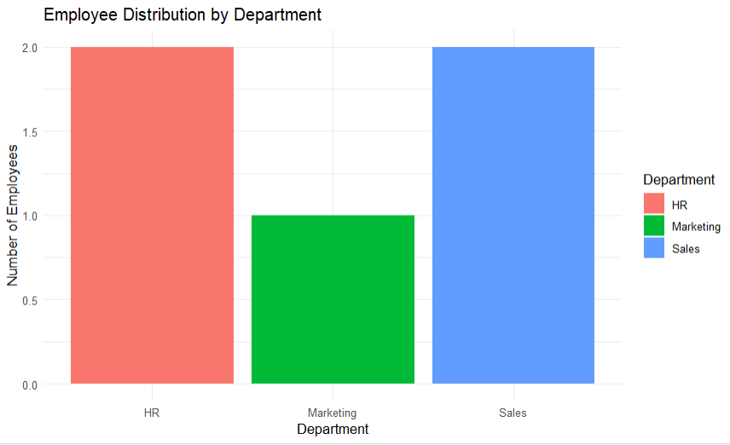
A bar chart showing the number of employees in each department.

Experiment 2: Line Chart (Performance Trend)
ggplot(employee,
aes(x = Years_of_Service,
y = Performance_Score,
group = 1)) +
geom_line(color = "blue",
linewidth = 1) +
geom_point(color = "red",
size = 3) +
labs(
title = "Employee Performance Trend",
x = "Years of Service",
y = "Performance Score"
) +
theme_minimal()
Output
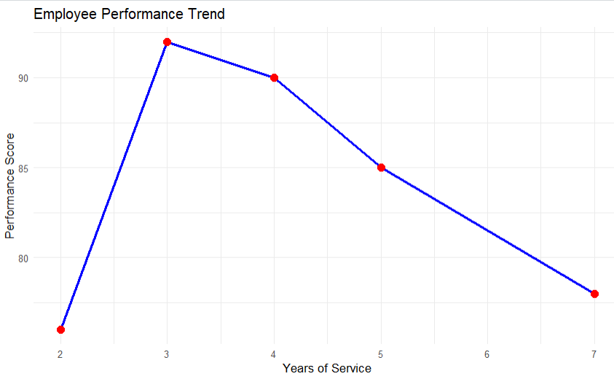
A line chart showing the trend between years of service and performance score.

Experiment 3: Tableau Dashboard
Step 1
Open Tableau Public or Tableau Desktop.
Step 2
Create an Excel file with the employee data (or export it from R) and connect it to Tableau.
Step 3: Create Worksheets
Worksheet 1 – Bar Chart
- Drag Department to Columns.
- Drag Number of Records to Rows.
- Set Marks to Bar.
- Drag Department to Color.
- Title: Employee Distribution by Department.
Worksheet 2 – Scatter Plot
- Create a new worksheet.
- Drag Years_of_Service to Columns.
- Drag Performance_Score to Rows.
- Set Marks to Circle.
- Drag Department to Color.
- Drag Employee_ID to Label.
- Title: Years of Service vs Performance Score.
Step 4: Create Dashboard
- Click Dashboard → New Dashboard.
- Add:
  - Bar Chart
  - Scatter Plot
Suggested Layout
+------------------------------------------------------+
| Department Distribution | Years of Service vs Score |
+------------------------------------------------------+
(Optional) Enable Use as Filter for interactive filtering.

Experiment 4: Employee Performance Table
View(employee)
# OR
print(employee)
Output
Employee ID | Department | Years of Service | Performance Score
1 | Sales | 5 | 85
2 | HR | 3 | 92
3 | Marketing | 7 | 78
4 | Sales | 4 | 90
5 | HR | 2 | 76

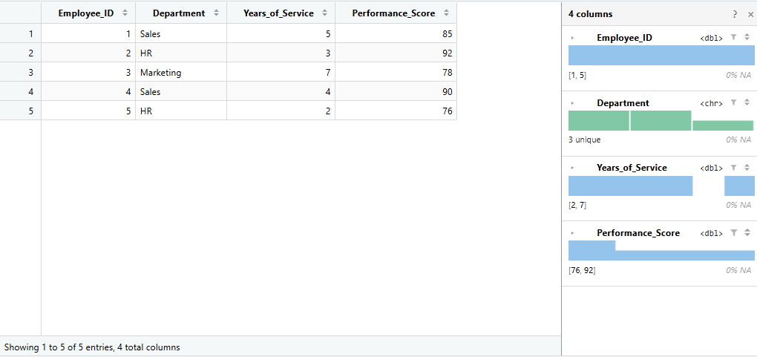

Set 24 Product Inventory Management
Dataset: Product Inventory
Product ID Product Name Quantity Available
1 Product A 250
2 Product B 175
3 Product C 300
4 Product D 200
5 Product E 220
1.In R, create a bar chart to visualize the quantity of each product in the inventory. Label the axes and title the chart.
2.In R, generate a stacked bar chart to show the quantity of each product within different product categories.
3.In Tableau, build a dashboard combining the bar chart and stacked bar chart for interactive exploration of inventory data.
4. In R, create a scatter plot to explore the relationship between product price and quantity available. Explain any insights.

Step 1: Create the dataset
inventory <- data.frame(
Product_ID = c(1, 2, 3, 4, 5),
Product_Name = c(
"Product A", "Product B", "Product C",
"Product D", "Product E"
),
Quantity_Available = c(250, 175, 300, 200, 220),
Category = c(
"Electronics", "Clothing", "Electronics",
"Clothing", "Electronics"
),
Price = c(20, 15, 18, 25, 22)
)

View(inventory)

1. Bar Chart — Quantity of Each Product
First install and load ggplot2:
install.packages("ggplot2")
library(ggplot2)
Then run:
ggplot(inventory,
aes(x = Product_Name,
y = Quantity_Available,
fill = Product_Name)) +
geom_bar(stat = "identity") +
labs(
title = "Product Inventory Quantity",
x = "Product Name",
y = "Quantity Available"
) +
theme_minimal()
Output
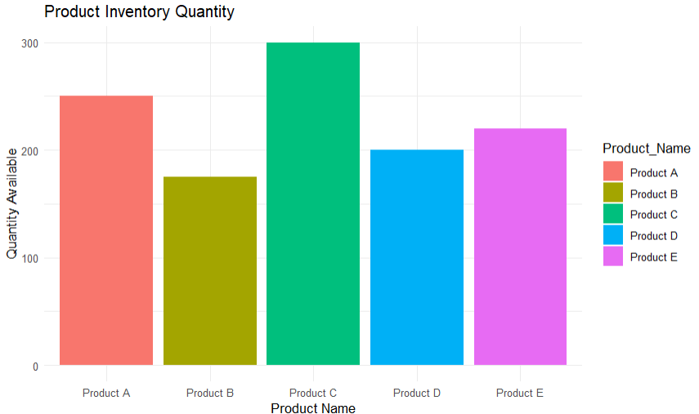
The chart compares the available quantity of Products A–E.
Observation: Product C has the highest inventory (300), while Product B has the lowest (175).

2. Stacked Bar Chart — Product Categories
ggplot(inventory,
aes(x = Category,
y = Quantity_Available,
fill = Product_Name)) +
geom_bar(stat = "identity") +
labs(
title = "Inventory by Product Category",
x = "Product Category",
y = "Quantity Available"
) +
theme_minimal()
This shows the total inventory within each category, with individual products stacked inside the category.
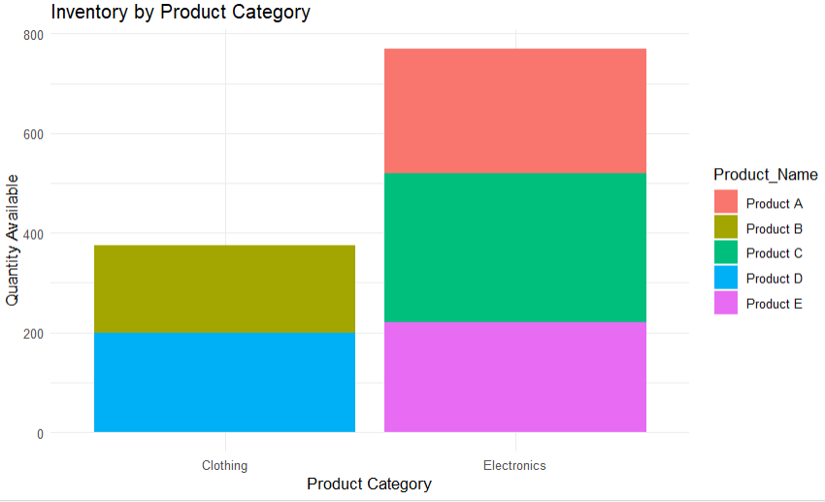

3. Tableau Dashboard
For Tableau, use the same data.
Create the Bar Chart
- Open Tableau.
- Connect to your inventory data.
- Drag Product_Name → Columns.
- Drag Quantity_Available → Rows.
- Select Bar under Marks.
- Drag Product_Name → Color.
Create the Stacked Bar Chart
Create another worksheet:
- Drag Category → Columns.
- Drag Quantity_Available → Rows.
- Drag Product_Name → Color.
- Select Bar.
Create Dashboard
Go to:
Dashboard → New Dashboard
Drag both worksheets into the dashboard.
Suggested layout:
+------------------------------------------------+
| Product Inventory Bar Chart |
+------------------------------------------------+
| Category-wise Stacked Bar Chart |
+------------------------------------------------+
You can add Category and Product Name as filters to make it interactive.

4. Scatter Plot — Price vs Quantity
ggplot(inventory,
aes(x = Price,
y = Quantity_Available)) +
geom_point(size = 4) +
geom_smooth(
method = "lm",
se = FALSE
) +
labs(
title = "Product Price vs Quantity Available",
x = "Product Price ($)",
y = "Quantity Available"
) +
theme_minimal()
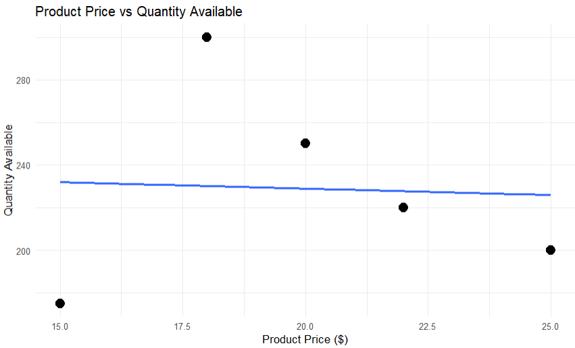
Interpretation
- Product C has a relatively low price ($18) and the highest quantity (300).
- Product D has the highest price ($25) and a quantity of 200.
- With only five products, the relationship between price and quantity is not strong enough to make a reliable conclusion.

Set 25: Website Traffic Analysis
Dataset: Website Traffic
Date Page Views Click-through Rate
2023-01-01 1500 2.3%

2023-01-02 1600 2.7%
2023-01-03 1400 2.0%
2023-01-04 1650 2.4%
2023-01-05 1800 2.6%
1. In Tableau, create a line chart to visualize the trend in page views over time. Label the axes and title the chart.
2. In R, generate a bar chart to show the top N days with the highest click-through rates. Label the chart elements.
3. In R, build a stacked area chart to display the distribution of user interactions (likes, shares, comments) on the website.
4. In Tableau, create a dashboard with an interactive map showing traffic sources and a bar chart displaying page views by source.

Step 1: Create the Dataset in R
traffic <- data.frame(
Date = as.Date(c(
"2023-01-01",
"2023-01-02",
"2023-01-03",
"2023-01-04",
"2023-01-05"
)),
Page_Views = c(1500, 1600, 1400, 1650, 1800),
Click_Through_Rate = c(2.3, 2.7, 2.0, 2.4, 2.6)
)

View(traffic)

1. Tableau — Line Chart for Page Views
This part is done in Tableau, not R.
Step 1
Open Tableau and connect to your website traffic data.
Step 2
Create a new worksheet.
Step 3
Drag:
- Date → Columns
- Page_Views → Rows
Step 4
Select Line from the Marks card.
Step 5
Add the title:
Website Page Views Trend
Expected chart
Page Views
1800 | ●
1700 | ●
1600 | ●
1500 | ●
1400 | ●
+---------------------------
Jan 1 Jan 2 Jan 3 Jan 4 Jan 5
Date

2. R — Top N Days by Click-Through Rate
Here we'll take Top 3 days.
library(ggplot2)

top_n <- 3

top_days <- traffic[
order(-traffic$Click_Through_Rate),
][1:top_n, ]

print(top_days)
Now create the bar chart:
ggplot(top_days,
aes(x = Date,
y = Click_Through_Rate)) +
geom_bar(stat = "identity") +
geom_text(
aes(label = paste0(Click_Through_Rate, "%")),
vjust = -0.5
) +
labs(
title = "Top 3 Days by Click-Through Rate",
x = "Date",
y = "Click-Through Rate (%)"
) +
theme_minimal()
Expected result
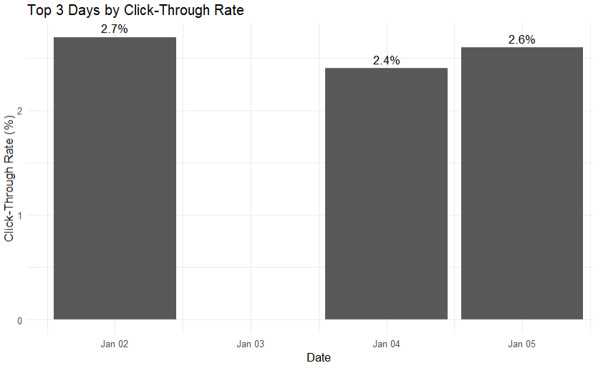
The top 3 days are:
Date | Click-through Rate
2023-01-02 | 2.7%
2023-01-05 | 2.6%
2023-01-04 | 2.4%

3. R — Stacked Area Chart
Because the original dataset doesn't contain user interactions, we'll add sample interaction data.
interactions <- data.frame(
Date = as.Date(c(
"2023-01-01",
"2023-01-02",
"2023-01-03",
"2023-01-04",
"2023-01-05"
)),
Likes = c(120, 140, 110, 150, 170),
Shares = c(50, 60, 45, 70, 80),
Comments = c(30, 35, 25, 40, 45)
)
View(interactions)
Convert the data to long format:
library(reshape2)
interaction_long <- melt(
interactions,
id.vars = "Date",
variable.name = "Interaction",
value.name = "Count"
)
Create the stacked area chart:
ggplot(
interaction_long,
aes(
x = Date,
y = Count,
fill = Interaction
)
) +
geom_area() +
labs(
title = "Website User Interactions",
x = "Date",
y = "Number of Interactions",
fill = "Interaction Type"
) +
theme_minimal()
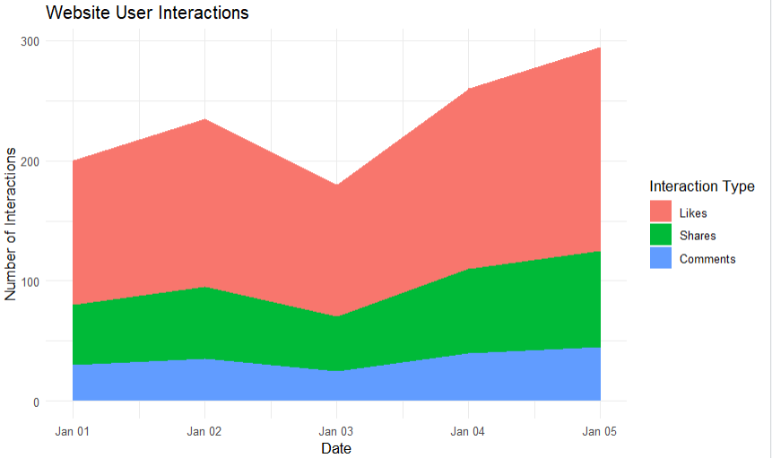
Chart contains
- Likes
- Shares
- Comments

4. Tableau — Interactive Map + Page Views by Source
The original dataset does not contain traffic sources or geographic locations, so create a second dataset with sample values.
For example:
Source | City | Page Views
Google | New York | 2500
Facebook | London | 1800
Instagram | Mumbai | 1500
YouTube | Sydney | 1200
Direct | Toronto | 1000
In Tableau
Create a data table containing:
Source
City
Page Views
Worksheet 1 — Interactive Map
- Drag City into the worksheet.
- Tableau should recognize it as a geographic field.
- Select Map.
- Drag Page Views → Size.
- Drag Source → Color.
- Drag Source → Label.
You now have a map showing traffic sources geographically.
Worksheet 2 — Page Views by Source
- Create a new worksheet.
- Drag Source → Columns.
- Drag Page Views → Rows.
- Select Bar.
- Add the title:
Page Views by Traffic Source
Create Dashboard
Go to:
Dashboard → New Dashboard
Drag both worksheets onto the dashboard:
+------------------------------------------------+
| |
| TRAFFIC SOURCE MAP |
| |
+------------------------------------------------+
| |
| PAGE VIEWS BY TRAFFIC SOURCE |
| |
+------------------------------------------------+
To make it interactive:
- Click the map.
- Select Use as Filter.
- Click a source/location on the map.
- The bar chart will update accordingly.

Final requirements
1. Page Views Line Chart
2. Top N Click-through Rate
3. Likes/Shares/Comments Area Chart
4. Traffic Source Map + Bar Chart
SET 26: Dataset: Student_Mini_Data.csv
Student_ID Gender Study_Hours Attendance Math_Score Science_Score Exam_Date
S01 Male 2.0 78 62 65 2025-01-10
S02 Female 3.5 90 80 85 2025-01-10
S03 Male 1.5 70 55 58 2025-02-12
S04 Female 4.0 95 90 92 2025-02-12
S05 Male 2.8 85 72 74 2025-03-15
S06 Female 3.0 92 82 86 2025-03-15
1. Import the dataset in R. Plot a histogram for Math_Score. Draw a boxplot of Science_Score by Gender. Add proper title and labels. Interpret the results.
2. Create a scatter plot using R programming between Study_Hours and Math_Score. Use different colors for Gender. Add a regression line. Explain the relationship between study time and performance.
3. Using R, Convert Exam_Date into Date format. Calculate monthly average Math scores. Plot a line chart for the trend. Apply moving average smoothing. Identify any increasing or decreasing pattern.
4. Import Student_Mini_Data.csv into Tableau. Create a bar chart showing average Math scores by Gender. Create a line chart for score trends over time. Add a filter for Exam_Date. Design a simple interactive dashboard.
1. Histogram and Boxplot
R Code
library(ggplot2)

student <- data.frame(
Student_ID = c("S01","S02","S03","S04","S05","S06"),
Gender = c("Male","Female","Male","Female","Male","Female"),
Study_Hours = c(2,3.5,1.5,4,2.8,3),
Attendance = c(78,90,70,95,85,92),
Math_Score = c(62,80,55,90,72,82),
Science_Score = c(65,85,58,92,74,86),
Exam_Date = c("2025-01-10","2025-01-10",
"2025-02-12","2025-02-12",
"2025-03-15","2025-03-15")
)

student$Exam_Date <- as.Date(student$Exam_Date)

# Histogram
ggplot(student, aes(x=Math_Score)) +
geom_histogram(binwidth=5, fill="skyblue", color="black") +
labs(
title="Distribution of Math Scores",
x="Math Score",
y="Number of Students"
) +
theme_minimal()

# Boxplot
ggplot(student, aes(x=Gender, y=Science_Score, fill=Gender)) +
geom_boxplot() +
labs(
title="Science Scores by Gender",
x="Gender",
y="Science Score"
) +
theme_minimal()
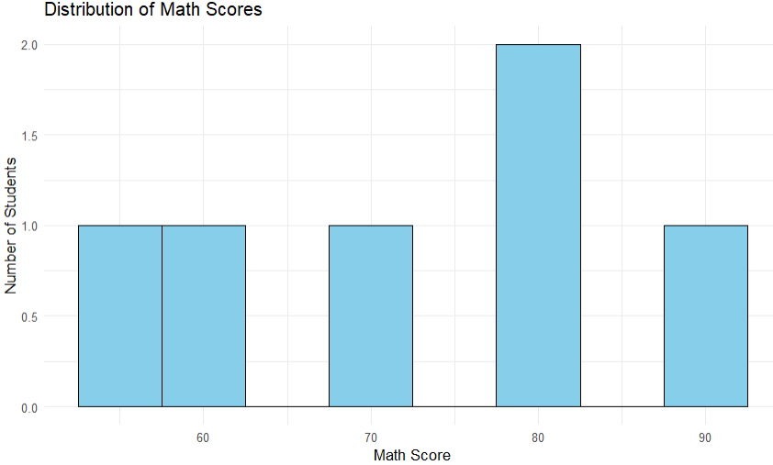
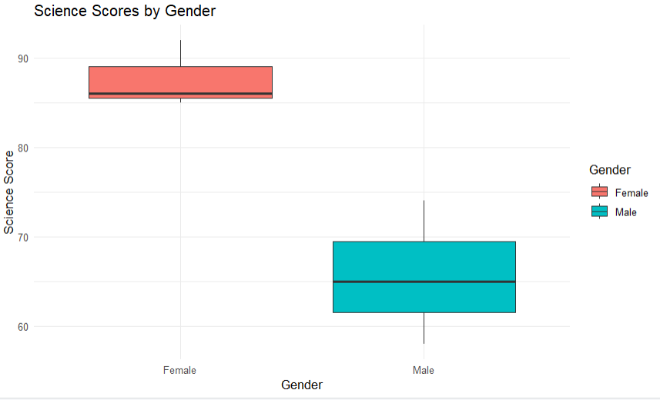
Interpretation
The histogram shows the distribution of Math scores. The boxplot shows that the female students generally have higher Science scores than the male students.

2. Scatter Plot – Study Hours vs Math Score
R Code
ggplot(student,
aes(x=Study_Hours,
y=Math_Score,
color=Gender)) +
geom_point(size=4) +
geom_smooth(method="lm", se=FALSE) +
labs(
title="Study Hours vs Math Score",
x="Study Hours",
y="Math Score",
color="Gender"
) +
theme_minimal()
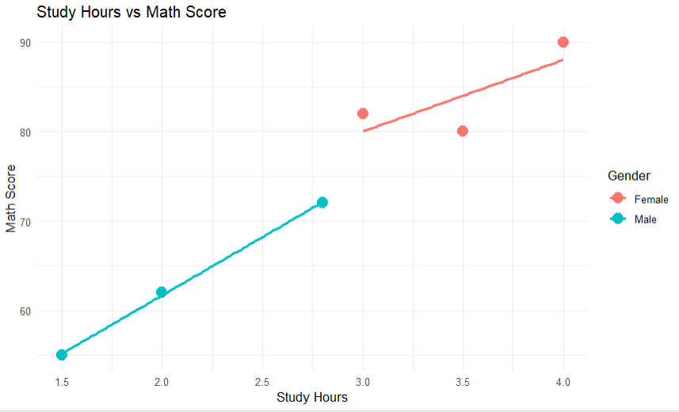
Interpretation
The scatter plot shows a positive relationship between study hours and Math scores. Students who spend more time studying generally obtain higher Math scores.

3. Monthly Average Math Score and Moving Average
R Code
student$Month <- format(student$Exam_Date, "%Y-%m")

monthly_avg <- aggregate(
Math_Score ~ Month,
data=student,
FUN=mean
)

names(monthly_avg)[2] <- "Average_Math"

# Moving average
monthly_avg$Moving_Average <- c(
NA,
mean(monthly_avg$Average_Math[1:2]),
mean(monthly_avg$Average_Math[2:3])
)

print(monthly_avg)

# Line chart
ggplot(monthly_avg, aes(x=Month)) +
geom_line(
aes(y=Average_Math, group=1),
linewidth=1
) +
geom_point(
aes(y=Average_Math),
size=3
) +
geom_line(
aes(y=Moving_Average, group=1),
linewidth=1,
linetype="dashed"
) +
labs(
title="Monthly Average Math Score Trend",
x="Month",
y="Average Math Score"
) +
theme_minimal()
Output
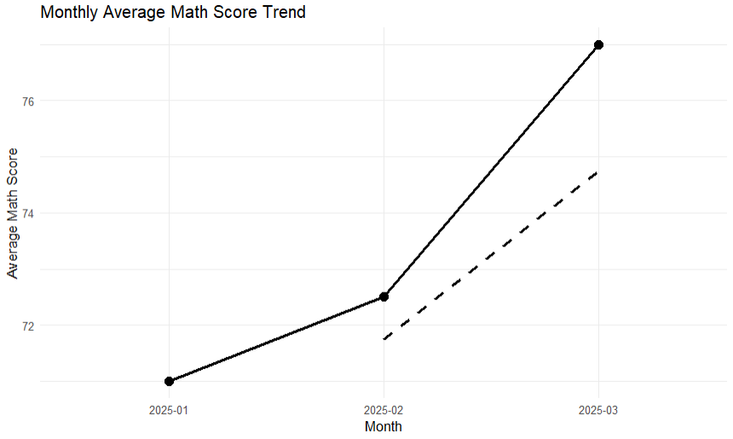
Month Average_Math
2025-01 71.0
2025-02 72.5
2025-03 77.0
Interpretation
The average Math score increases from 71 to 77, showing an increasing performance trend from January to March.

4. Tableau Dashboard
Step 1 – Import Dataset
Import Student_Mini_Data.csv into Tableau.
Step 2 – Bar Chart
Use:
Gender → Columns
Math_Score → Rows
Change SUM(Math_Score) to Average.
Title:
Average Math Score by Gender
Step 3 – Line Chart
Use:
Exam_Date → Columns
Math_Score → Rows
Select Line Chart.
Title:
Math Score Trend Over Time
Step 4 – Filter
Drag:
Exam_Date → Filters
Select Show Filter.
Step 5 – Dashboard
Create New Dashboard and add:
- Average Math Score by Gender
- Math Score Trend Over Time
- Exam Date filter
Result: An interactive dashboard for exploring student performance by gender and examination date.

SET 27.
Patient Health Risk Analysis
Patient\_ID Age BMI BP Cholesterol
P1 25 22 120 180
P2 40 28 135 210
P3 55 30 145 240
P4 35 26 130 200
P5 60 32 150 260
1. Using R, create a scatterplot matrix for Age, BMI, BP, and Cholesterol.Examine pairwise relationships to identify strong correlations, clusters, or potential risk patterns.
2. Construct Q-Q plot and ECDF for Cholesterol levels to assess distribution behaviour. Comment on normality assumption and skewness.
3. Using R, create a bar chart showing the average values of each health indicator (Age, BMI,BP, Cholesterol). Include axis labels, a descriptive title, and distinct colors for each bar. How do these averages relate to general patient health risk
4. Create an interactive Tableau dashboard with a heatmap highlighting high-risk patients and an Age filter for exploring risk patterns. Include hover tooltips showing all health indicators. Analyze which patients are highest risk, how age affects risk, and how this dashboard can aid healthcare professionals in prioritizing care.
1. Scatterplot Matrix
R Code
pairs(
patient[, c("Age","BMI","BP","Cholesterol")],
main = "Scatterplot Matrix of Health Indicators",
pch = 19
)
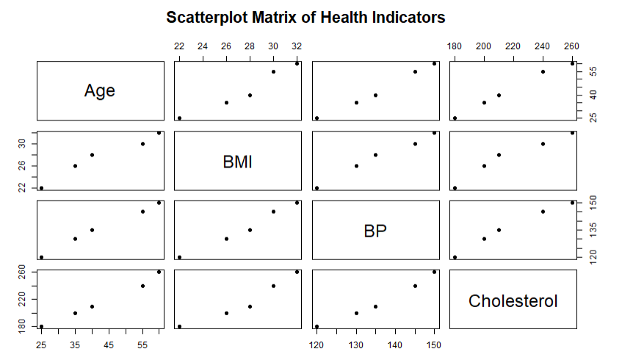
Interpretation
The scatterplot matrix shows positive relationships between Age, BMI, BP, and Cholesterol. Older patients generally have higher BMI, blood pressure, and cholesterol levels. Patient P5 shows particularly high-risk values.

2. Q-Q Plot and ECDF for Cholesterol
Q-Q Plot
qqnorm(
patient$Cholesterol,
main = "Q-Q Plot of Cholesterol"
)

qqline(
patient$Cholesterol,
col = "red"
)
ECDF
plot(
ecdf(patient$Cholesterol),
main = "ECDF of Cholesterol Levels",
xlab = "Cholesterol",
ylab = "Cumulative Probability"
)
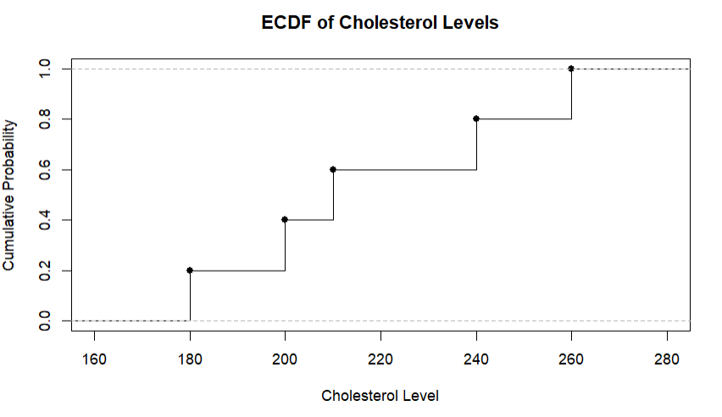
Interpretation
The Q-Q plot is used to compare cholesterol values with a normal distribution. Because the dataset contains only five observations, normality cannot be reliably determined. The ECDF shows the cumulative distribution of cholesterol values from 180 to 260.

3. Average Health Indicators Bar Chart
R Code
averages <- c(
Age = mean(patient$Age),
BMI = mean(patient$BMI),
BP = mean(patient$BP),
Cholesterol = mean(patient$Cholesterol)
)
barplot(
averages,
col = c("skyblue","orange","green","red"),
main = "Average Health Indicators",
xlab = "Health Indicators",
ylab = "Average Value"
)
Average Values
Age = 43
BMI = 27.6
BP = 136
Cholesterol = 218
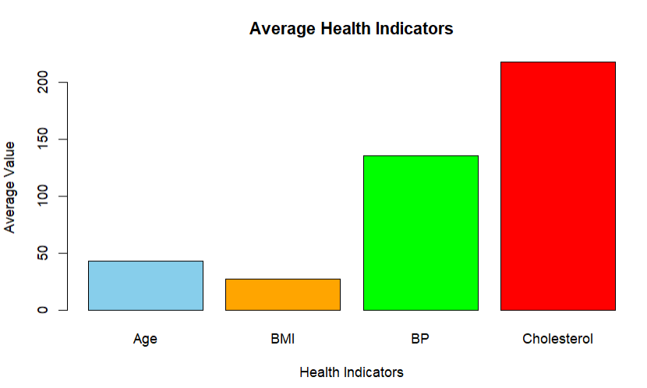
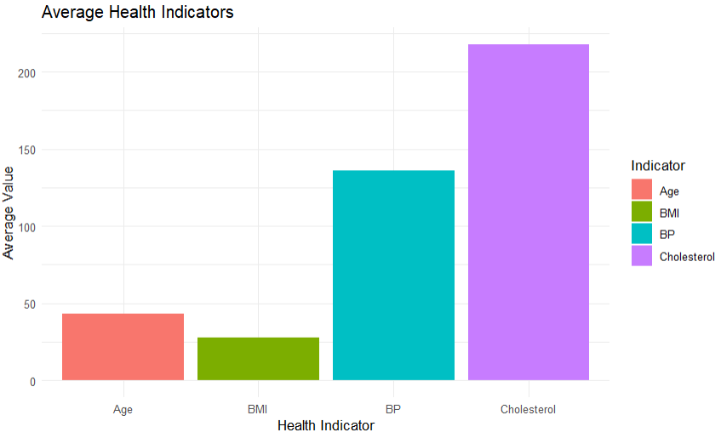
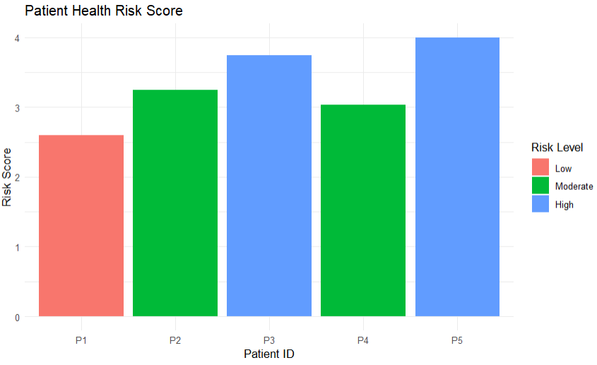
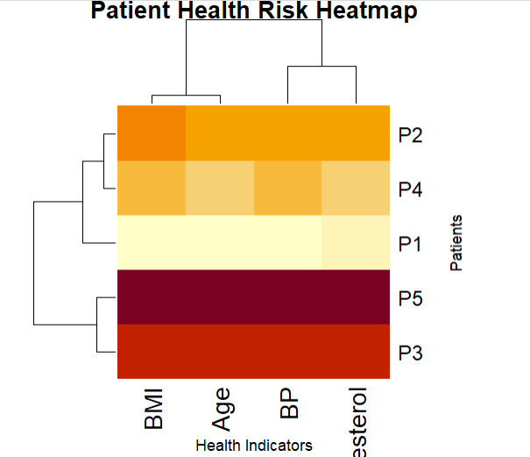
Interpretation
The average values provide an overall view of the patient group. Higher BMI, BP, and cholesterol can indicate increased health risk, although proper clinical risk assessment requires medical reference ranges and additional patient information.

4. Tableau Dashboard
Step 1 – Create Heatmap
Import the patient dataset into Tableau.
Drag:
Age → Columns
Patient_ID → Rows
Drag:
Cholesterol → Color
Also add:
BMI → Label
BP → Label
Cholesterol → Label
Age → Label
Choose Square marks.
Step 2 – Add Age Filter
Drag:
Age → Filters
Select Show Filter.
Step 3 – Add Tooltip
Click Tooltip and include:
Patient ID
Age
BMI
BP
Cholesterol
Step 4 – Create Dashboard
Create:
Dashboard → New Dashboard
Add the heatmap and Age filter.
Risk Analysis
Based on the given values, P5 has the highest combination of age, BMI, BP, and cholesterol and therefore appears to have the highest risk profile in this small dataset. P3 also shows elevated values and may require attention.
The dashboard allows healthcare professionals to quickly filter patients by age and identify patients with multiple elevated indicators for further assessment.

